**PAF-Karachi Institute of Economics and Technology College of Computing and Information Sciences - North Campus**

**Artificial Intelligence**

**Assignment – 1**

**Instruction:**

1. Assignment must be handwritten on A4 or Notebook pages, neat.
2. You can search about anything on google but write in your own wordings.
3. Don’t Copy from others, in case Marked Zero.

**Submission Deadline [23/7/2022] – in class timings ONLY.**

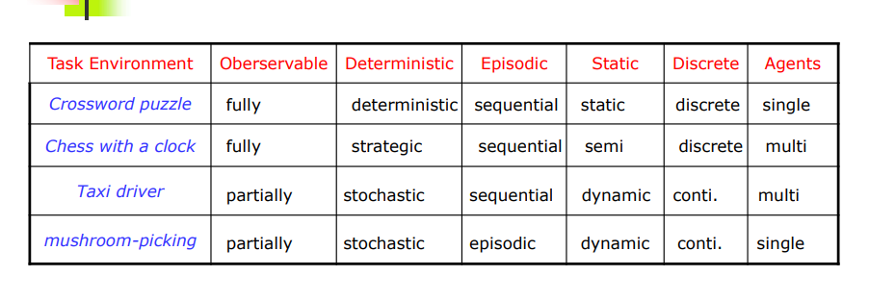

1. Task Environment are some examples of agents. You are required to explain how each agent is Observable, deterministic, episodic, static, and discrete. [Work on already filled terms just explain].

**For Example:**

**Your answers should be like:**

|  |  |  |  |  |  |  |
| --- | --- | --- | --- | --- | --- | --- |
| **Crossword puzzle** | **observable** | **deterministic** | **episodic** | **static** | **discrete** | **agents** |
|  | In crossword puzzle an agent knows the total condition of an environment through its sensors. | Since our next turn rely upon the past worth. | the ongoing worth value be anything as per the game | Crossword puzzle is a single agent game that is the reason its static | Crossword puzzle has a limited no of distinct states | An agent solving a crossword puzzle without anyone else is obviously in a single agent |

|  |  |  |  |  |  |  |
| --- | --- | --- | --- | --- | --- | --- |
| **Chess with a clock** | **observable** | **deterministic** | **episodic** | **static** | **discrete** | **agents** |
|  | Chess is fully observable because **the player can see the places of all dynamic pieces on the chess board, and that is all the data that should be known to make the ideal move.** | because he purpose is to keep track of the total time each player takes for their own moves. | Chess with a clock are sequential in light of the fact that momentary activities can have long haul outcomes. | Time is most certainly a unique component in chess. Space anyway isn't so effortlessly characterized. It relies upon the position. Assuming a player has a strong hold in space that isn't effectively retaken by the rival, then all things considered space is a static component. In the event that the space advantage is impermanent, space turns into the powerful element. Material and pawn designs are most certainly static. Also, long haul characteristics don't mean they are super durable nor do they persevere from opening to final plan. It is only that they don't change that without any problem. | There are a fixed numbers of possible moves on each turn | in chess with a clock there is more than one agent since chess game can't done by a single agent |

|  |  |  |  |  |  |  |
| --- | --- | --- | --- | --- | --- | --- |
| **Taxi driver** | **observable** | **deterministic** | **episodic** | **static** | **discrete** | **agents** |
|  | An environment may be to some degree perceptible in view of noisy and off base sensors missing from the sensor data. partially because a driver has no knoweldge about each direction. | Taxi driving is obviously stochastic in this sense, since one can neverpredict the way of behaving of traffic precisely, also, one's tires blow outand one's engine seizes up all of a sudden. | taxi driving are sequential in light of the fact that momentary activities can have long haul results. | Taxi driving is obviously dynamic, different vehicles and the actual taxi continue moving while the driving algorithm oscillate about what to do straightaway | The speed and area of the taxi move throughout a scope of continous value | In a taxi driving environment, staying away from impacts boosts the exhibition measure. Of all agents, so it is somewhat agreeable multi agent environment. |

|  |  |  |  |  |  |  |
| --- | --- | --- | --- | --- | --- | --- |
| **Mashroom picking** | **observable** | **deterministic** | **episodic** | **static** | **discrete** | **agents** |
|  | Mashroom picking robot (a robot that picks up mashroom and places them in a new location) | stochastic because new pickup step does'nt depend on previous step. | episodic because it work one by one episodically. | environment can be change because agent can go anywhere to pick whereever we want to take it | continous: unlimited number of percepts because no of mushrooms can be larger. | single agent to pick up the mushrooms. |